**Windows 10 UWP – Hands on Lab**

**Lab 4:**

**Note**: The demo app created for this lab uses Visual Studio 2015 with the latest Windows Tools SDK version 10240. To help with our coding efforts with the boiler code and page navigation we use a UWP app extension called Template 10.

1. Open the \Views\MainPage.xaml file and add the following lines of xaml code to line 19.

<VisualStateManager.VisualStateGroups>

            <VisualStateGroup x:Name="AdaptiveVisualStateGroup">

                <VisualState x:Name="NarrowState">

                    <VisualState.StateTriggers>

                        <AdaptiveTrigger MinWindowWidth="{StaticResource NarrowMinWidth}" />

                    </VisualState.StateTriggers>

                    <VisualState.Setters>

                        <Setter Target="RecipesGridView.Visibility" Value="Collapsed" />

                        <Setter Target="RecipesListView.Visibility" Value="Visible" />

                    </VisualState.Setters>

                </VisualState>

                <VisualState x:Name="MediumState">

                    <VisualState.StateTriggers>

                        <AdaptiveTrigger MinWindowWidth="{StaticResource NormalMinWidth}" />

                    </VisualState.StateTriggers>

                    <VisualState.Setters>

                        <Setter Target="RecipesGridView.Visibility" Value="Collapsed" />

                        <Setter Target="RecipesListView.Visibility" Value="Visible" />

                    </VisualState.Setters>

                </VisualState>

                <VisualState x:Name="WideState">

                    <VisualState.StateTriggers>

                        <AdaptiveTrigger MinWindowWidth="{StaticResource WideMinWidth}" />

                    </VisualState.StateTriggers>

                    <VisualState.Setters>

                        <Setter Target="RecipesGridView.Visibility" Value="Visible" />

                        <Setter Target="RecipesListView.Visibility" Value="Collapsed" />

                    </VisualState.Setters>

                </VisualState>

            </VisualStateGroup>

        </VisualStateManager.VisualStateGroups>

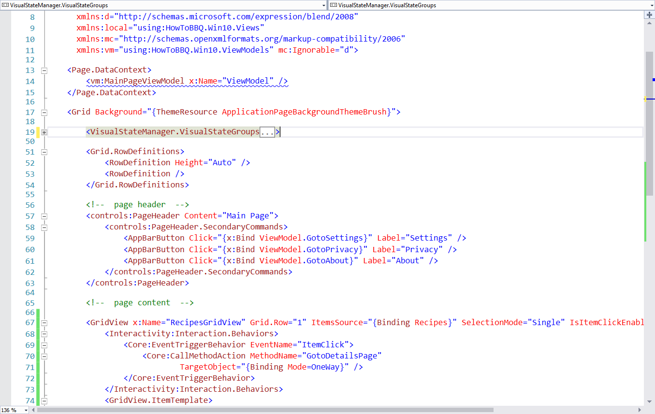

1. In the \Views\MainPage.xaml file and add the following lines of xaml code to line 86. This will be added after the GridView control.

        <ListView x:Name="RecipesListView"

                  Grid.Row="1"

                  ItemsSource="{Binding Recipes}"

                  SelectionMode="Single"

                  IsItemClickEnabled="True"

                  HorizontalAlignment="Left"

                  VerticalAlignment="Center"

                  Visibility="Collapsed">

            <Interactivity:Interaction.Behaviors>

                <Core:EventTriggerBehavior EventName="ItemClick">

                    <Core:CallMethodAction MethodName="GotoDetailsPage"

                            TargetObject="{Binding Mode=OneWay}" />

                </Core:EventTriggerBehavior>

            </Interactivity:Interaction.Behaviors>

            <ListView.ItemTemplate>

                <DataTemplate>

                    <Grid>

                        <Image Source="{Binding ImagePath}"/>

                        <Border Background="#99000000" VerticalAlignment="Bottom">

                            <TextBlock Text="{Binding Name}"

                 FontSize="32" Margin="10,0,0,0"/>

                        </Border>

                    </Grid>

                </DataTemplate>

            </ListView.ItemTemplate>

        </ListView>

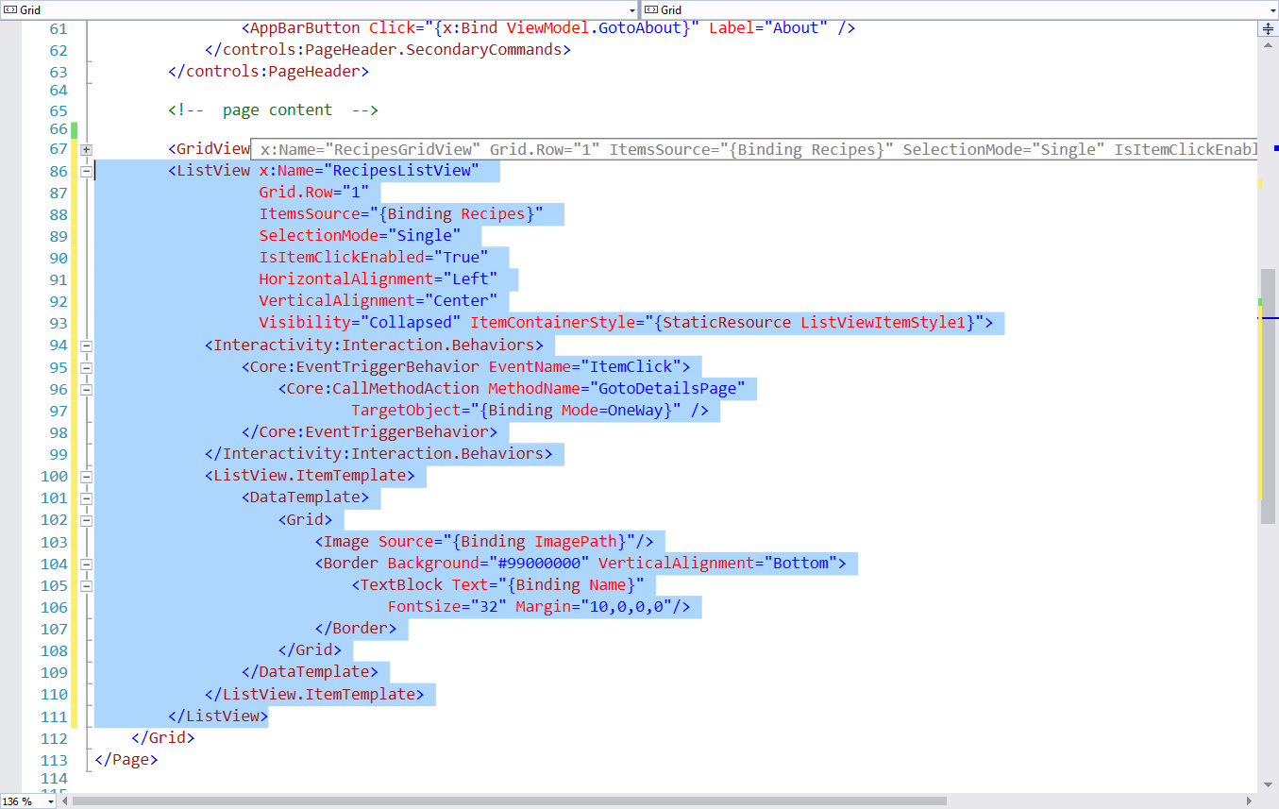

1. Open the \Views\DetailPage.xaml file and add the following lines of xaml code to line 19.

<VisualStateManager.VisualStateGroups>

            <VisualStateGroup x:Name="AdaptiveVisualStateGroup">

                <VisualState x:Name="VisualStateNarrow">

                    <VisualState.StateTriggers>

                        <AdaptiveTrigger MinWindowWidth="{StaticResource NarrowMinWidth}" />

                    </VisualState.StateTriggers>

                    <VisualState.Setters>

                        <Setter Target="BBQImage.Height" Value="300" />

                        <Setter Target="BBQImage.Width" Value="300" />

                        <Setter Target="DetailstackPanel.(RelativePanel.Below)" Value="ImageStackPanel" />

                        <Setter Target="DetailstackPanel.Margin" Value="0,0,0,0"/>

                    </VisualState.Setters>

                </VisualState>

                <VisualState x:Name="VisualStateNormal">

                    <VisualState.StateTriggers>

                        <AdaptiveTrigger MinWindowWidth="{StaticResource NormalMinWidth}" />

                    </VisualState.StateTriggers>

                    <VisualState.Setters>

                        <Setter Target="BBQImage.Height" Value="300" />

                        <Setter Target="BBQImage.Width" Value="300" />

                       <Setter Target="DetailstackPanel.(RelativePanel.Below)" Value="ImageStackPanel" />

                        <Setter Target="DetailstackPanel.Margin" Value="0,0,0,0"/>

                    </VisualState.Setters>

                </VisualState>

                <VisualState x:Name="VisualStateWide">

                    <VisualState.StateTriggers>

                        <AdaptiveTrigger MinWindowWidth="{StaticResource WideMinWidth}" />

                    </VisualState.StateTriggers>

                    <VisualState.Setters>

                        <Setter Target="BBQImage.Height" Value="800" />

                        <Setter Target="BBQImage.Width" Value="600" />

                        <Setter Target="DetailstackPanel.(RelativePanel.RightOf)" Value="ImageStackPanel"/>

                        <Setter Target="DetailstackPanel.(RelativePanel.AlignBottomWith)" Value="ImageStackPanel" />

                        <Setter Target="DetailstackPanel.Margin" Value="50,0,0,0"/>

                    </VisualState.Setters>

                </VisualState>

            </VisualStateGroup>

        </VisualStateManager.VisualStateGroups>

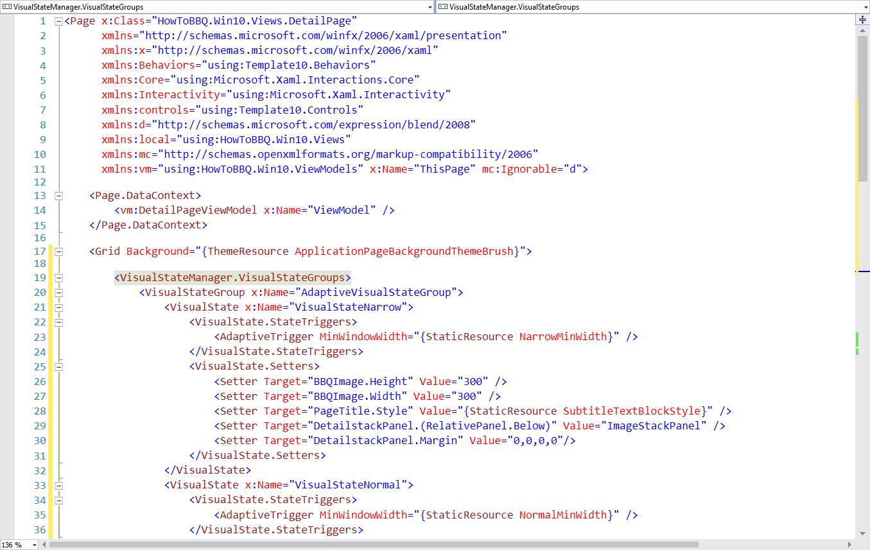

1. In the \Views\DetailPage.xaml file we are going to take advantage of using the new RelativePanel control to allows us to control the placement of other controls based on the changes of visual state from tablet and mobile modes. Collaspe the StackPanel control within the ScrollViewer control. We need to replace this control with the RelativePanel control.

